

Annexure

Business Intelligence and Data Visualization CSL 232

Project Report

Faculty name: Poonam Chaudhary

Student

Name: Deepak Yadav
Roll no: 21csu577
Section: DS-B(6)
Department of Computer Science and Engineering The NorthCap University, Gurugram- 122001, IndiaSession 2021-2025

1

Table of Contents

S.No |  | Page No.
1. | Abstract Project Description | 3-14
2. | Project Description Problem Statement | 15-16
3. | Problem Statement | 17
4. | - Charts  - Graphs  - Descriptions | 18-23
6. | Output(Screenshots) | 24-28
7. | Conclusion and Future Scope | 29

2

Abstract

This project presents a detailed exploration of historical stock market data for prominent companies traded on NASDAQ, employing advanced data visualization techniques through Tableau. The dataset encompasses daily price records, offering a comprehensive analysis of market trends, trading volumes, and price fluctuations up until April 1, 2020. Through a series of interactive and insightful visualizations, including Candlestick charts, Pie charts, and multiple charts, the project provides a user-friendly platform for investors to understand long-term company performance. The visualizations, enhanced with filters and selection options, facilitate focused analyses and empower users with actionable insights. This project not only simplifies complex financial data but also equips investors with valuable tools for making informed decisions and identifying potential investment opportunities. The study showcases the transformative power of data visualization in deciphering intricate market patterns, making it an essential resource for investors seeking to navigate the dynamic landscape of the stock market.

Project Description

NASDAQ Historical Stock Price Analysis Dashboard

In this Tableau project, titled "NASDAQ Historical Stock Price Analysis Dashboard," the dataset provides a detailed account of daily prices for all NASDAQ-traded companies up to April 1, 2020. The objective is to create a comprehensive financial analysis tool, enabling users to explore historical price trends, moving averages, trading volumes, and price change distributions. Interactive features, including date filters and company selectors, enhance user experience and customization. By leveraging this rich dataset, the dashboard aims to empower investors with actionable insights, aiding them in tracking market behavior, understanding volatility, and making informed investment decisions. This project serves as a vital resource for both novice and experienced investors, offering deep insights into NASDAQ market dynamics and historical stock performance.
We're creating a tool that makes it easy for people to see how stock prices have changed over time, understand moving averages, and check trading volumes. There are interactive features like date filters and company selectors for a more customized experience. The goal is to help investors make informed decisions by providing insights into market trends and volatility. This project is a valuable resource for both new and experienced investors, giving them a better understanding of how NASDAQ stocks have performed over time.

Problem Statement

"Investors and financial analysts face challenges in efficiently analyzing historical stock data for NASDAQ-listed companies. Access to comprehensive and user-friendly tools is essential for making informed investment decisions. The absence of a centralized and interactive platform hampers the ability to discern market trends, assess trading volumes, and identify potential investment opportunities. The goal is to create a solution that provides a visual representation of historical stock prices, offering insights into price trends, volume fluctuations, and market behavior. This tool should be intuitive, interactive, and customizable, allowing users to analyze specific companies within defined study periods, facilitating better understanding and decision-making in the complex realm of stock investments."








- VISUALIZE THE VOLUME FOR DIFFERENT COMPANIES DEPENDING ON DATE
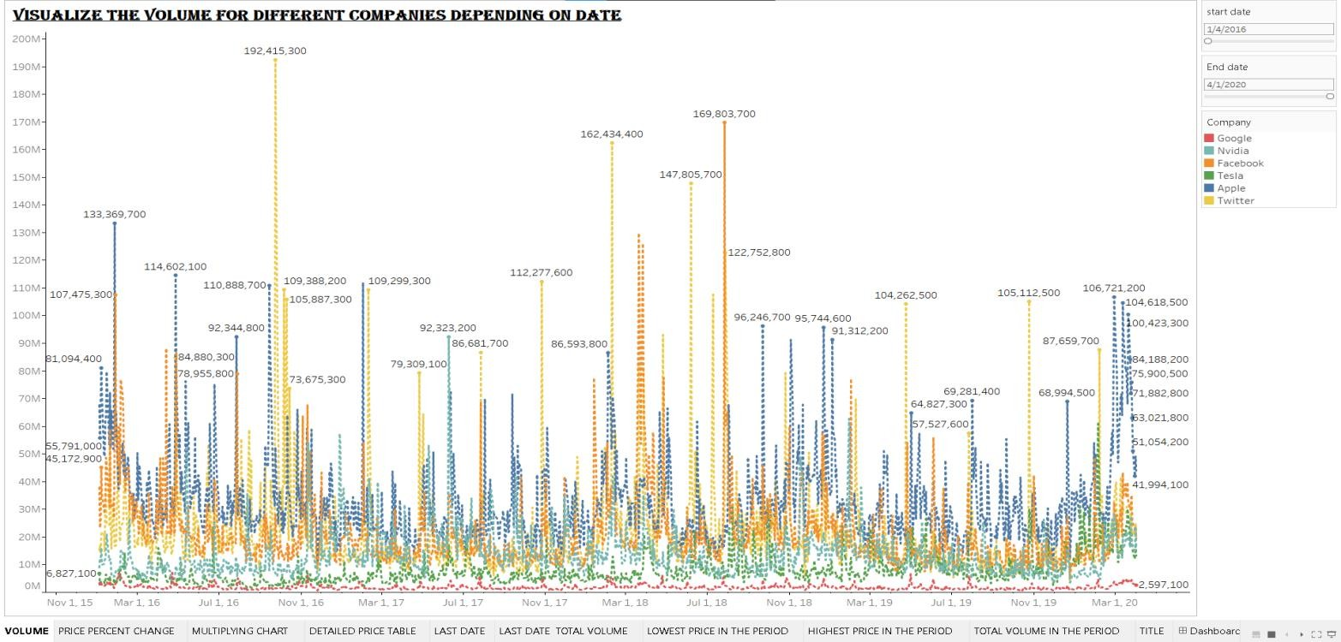

This visualization illustrates the trading volume of various companies over different dates. The X-axis represents dates, the Y-axis indicates trading volume, and each company is represented by a distinct color. By using the study period filter, users can focus on a specific timeframe for analysis. This graph provides a clear comparison of how trading volumes fluctuate across multiple companies over time, aiding in identifying trends, market activity patterns, and potential trading opportunities. It helps investors comprehend which companies experienced heightened or reduced trading activity during the chosen period, offering valuable insights for investment decision-making.

- Histogram
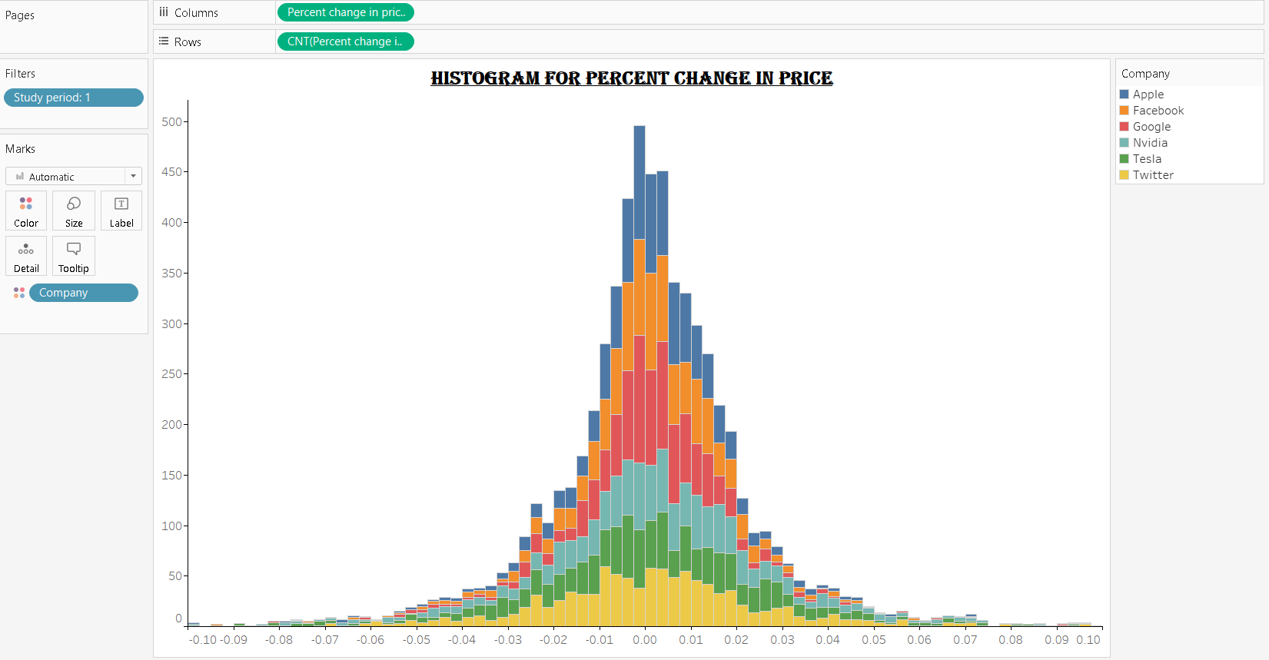

Creating a histogram in Tableau with the study period as a filter, percent change in price on the X-axis, and the count of percent change in price on the Y-axis will display the distribution of price changes for different companies within the specified period. Each bar represents a range of percent changes, showing how frequently those changes occurred across various companies. The color differentiation represents different companies, allowing for a comparison of their price change distributions. This visualization helps identify common trends or outliers in price movements during the selected study period for different companies, providing insights into market behavior and volatility.

- multiplying chart for moving average and open price

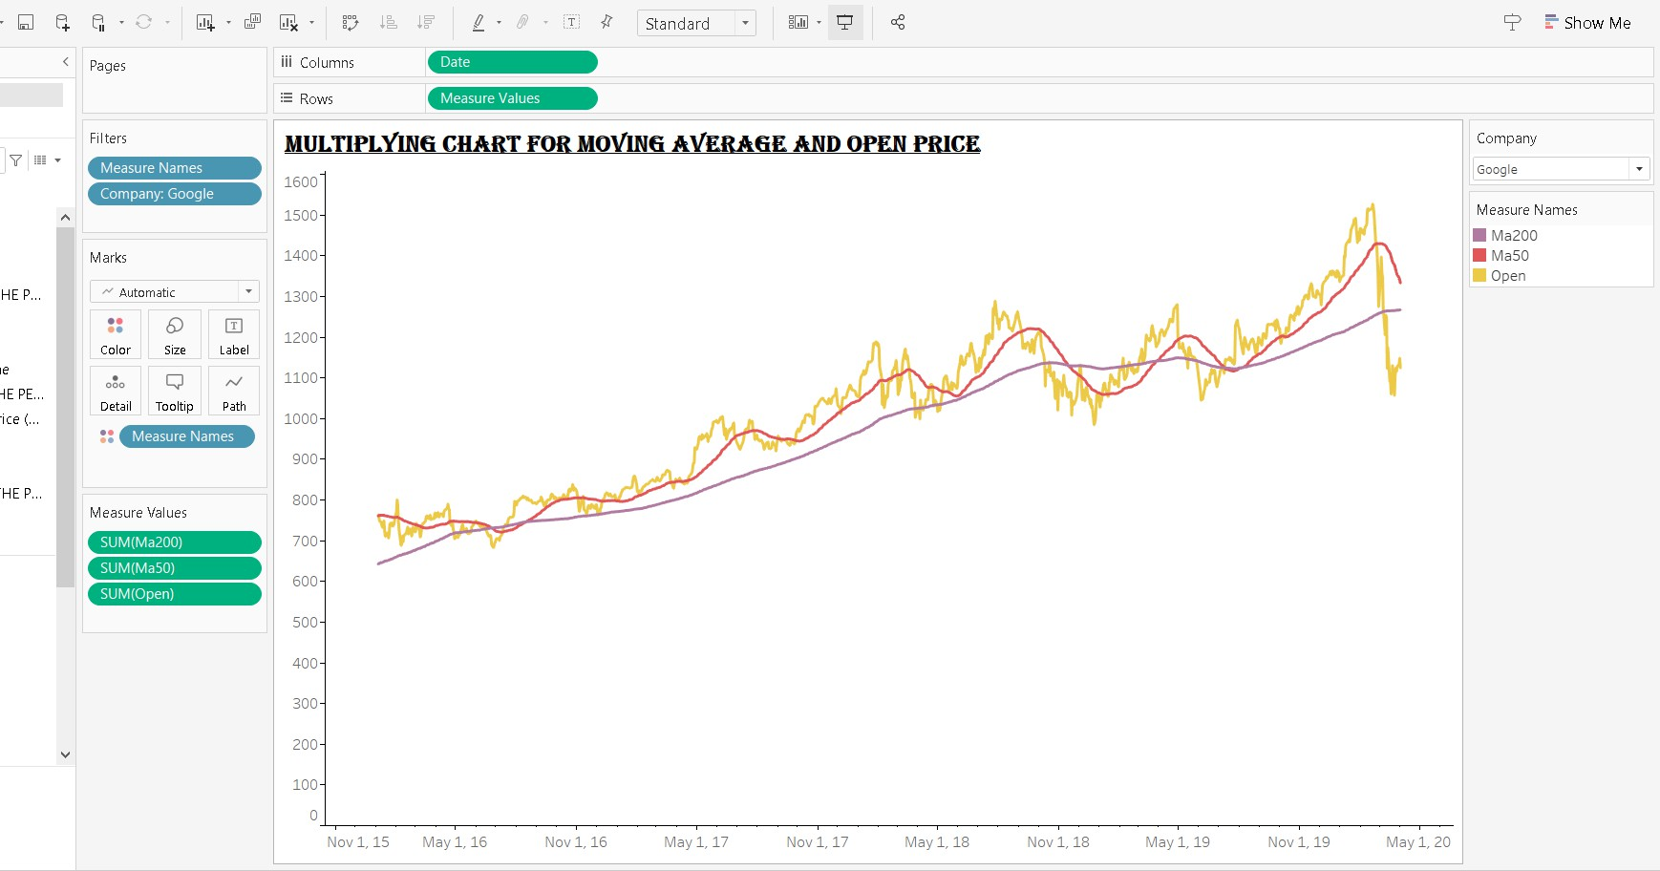

Creating a multiple line chart in Tableau with dates on the X-axis and measure values (MA50, MA200, and Open Price) on the Y-axis allows for a comparison of Google's moving averages (MA50 and MA200) and open prices over time. The lines represent the trends of the moving averages (50- day and 200-day) and the open prices on the same chart. By color-coding the lines based on the measure names, this visualization enables a clear comparison between Google's short-term and long- term moving averages alongside its open prices. Users can analyze the relationship between these metrics and identify potential patterns or crossovers, aiding in investment analysis and decision- making.

Detailed priced table

- TO DISPLAY CLOSE PRICE OF THE LAST DATE
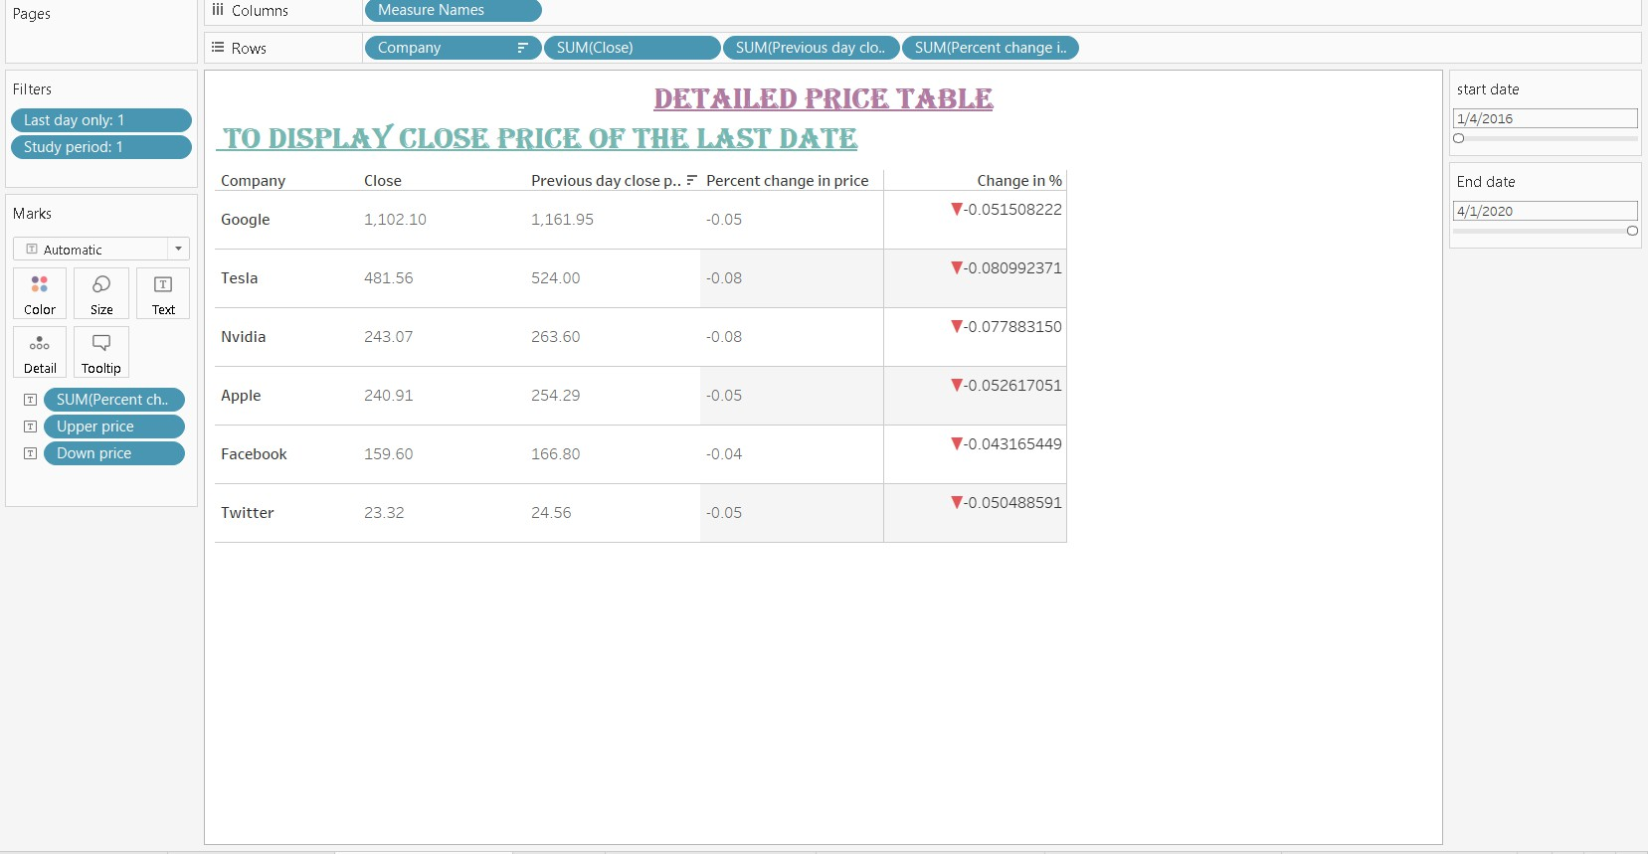

Creating a detailed price table in Tableau displays key metrics for companies on the last trading day within the specified study period. Columns represent different measures (Close Price, Previous Day Close, Percent Change), while rows display company names and corresponding values. Filters ensure data is limited to the last trading day and the selected study period. The table includes Close Price, Previous Day Close, and Percent Change in Price, differentiating between upward and downward price movements. This visualization offers a precise snapshot of a company's closing data on the latest trading day, aiding in quick comparisons and analysis of price movements.

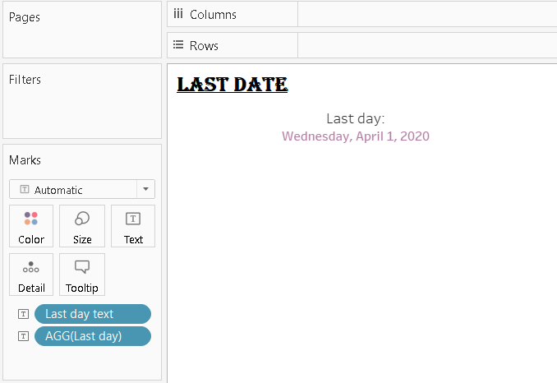
- LAST DATE
Creating a visualization with "Last Day" as text and aggregated values of the last day displayed in the text marks provides a clear and concise representation of the latest available data. The "Last Day" text indicates the context of the displayed information, ensuring users understand that the values pertain to the most recent date in the dataset. By aggregating the data for this specific day, users can instantly see key metrics such as total sales, total volume, or any other relevant measure. This presentation method simplifies data interpretation, allowing users to focus solely on the latest data point and make timely decisions based on current information.

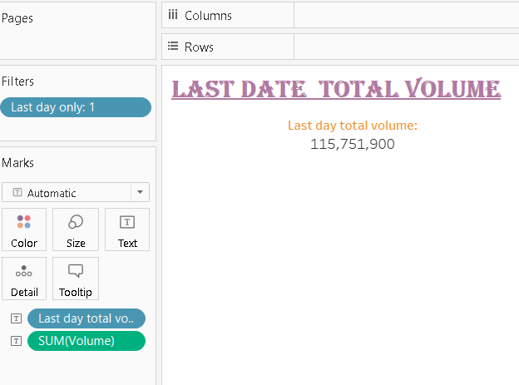
- LAST DATE TOTAL VOLUME
By using "Last Day" as a filter and displaying "Total Volume" (sum of volume) for that specific date in the text marks, the visualization provides a direct insight into the aggregated trading activity of all companies on the most recent trading day. This approach ensures that users focus solely on the latest available data, offering a clear understanding of the overall market activity in terms of total volume traded. Users can quickly grasp the scale of trading for that specific day,

aiding in assessments of market liquidity and investor participation, which are vital for making informed trading decisions.
- LOWEST PRICE IN THE PERIOD
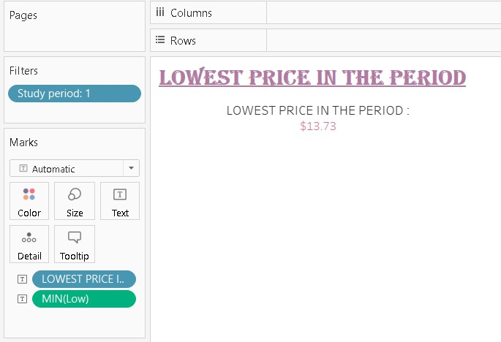
This visualization displays the "Lowest Price in the Period" by filtering the data for Study Period. The "Lowest Price in the Period" text indicates the context, focusing on the minimum recorded price during the specified period. By aggregating the data using "min(low)," the visualization shows the lowest price observed among all companies within the chosen timeframe. This information is vital for investors assessing potential entry points or evaluating market performance, as it highlights the most affordable price point reached during the specified period, aiding in strategic decision-making.

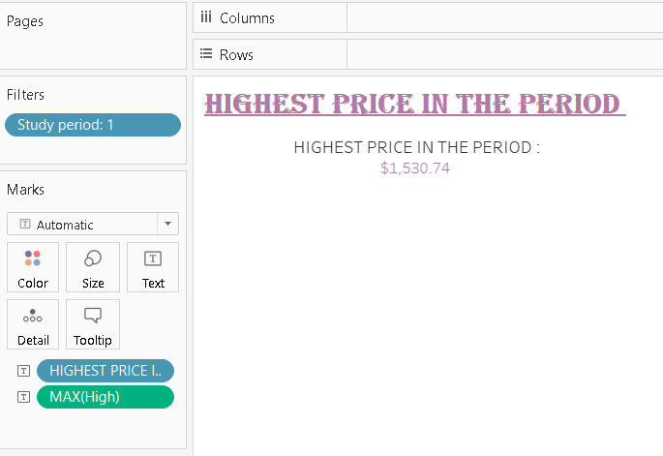
- HIGHEST PRICE IN THE PERIOD

This visualization displays the "Highest Price in the Period" by utilizing the maximum high price data within the selected study period. By filtering the data based on the specified study period, the visualization presents the maximum price reached by any company during that timeframe. The "Highest Price in the Period" text clarifies the context, focusing on the peak price level observed across all companies. This information is crucial for investors, indicating the highest price point

reached, potentially representing market peaks or valuable investment opportunities within the specified period, aiding in strategic decision-making and market analysis.
- TOTAL VOLUME IN THE PERIOD
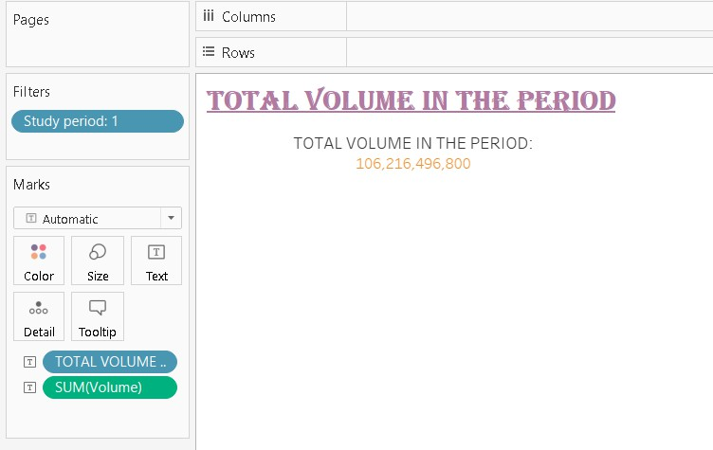
This visualization displays the "Total Volume in the Period" by summing up the trading volumes of all companies within the selected study period. By using the "sum(volume)" data and filtering based on the specified study period, the visualization presents the overall trading activity during that timeframe. The "Total Volume in the Period" text clarifies the context, indicating the combined volume of shares exchanged across all companies. This information is vital for assessing market liquidity and investor participation, offering insights into the overall trading intensity within the specified period, aiding in market analysis and investment decision-making.

- Title

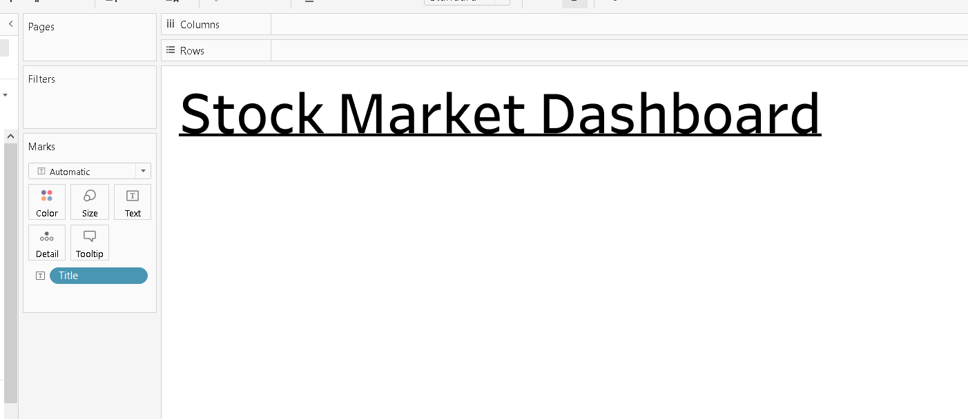

- Dashboard
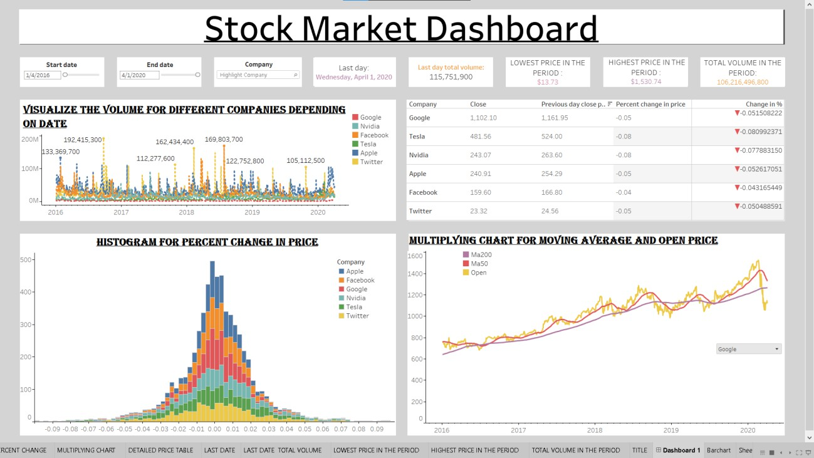

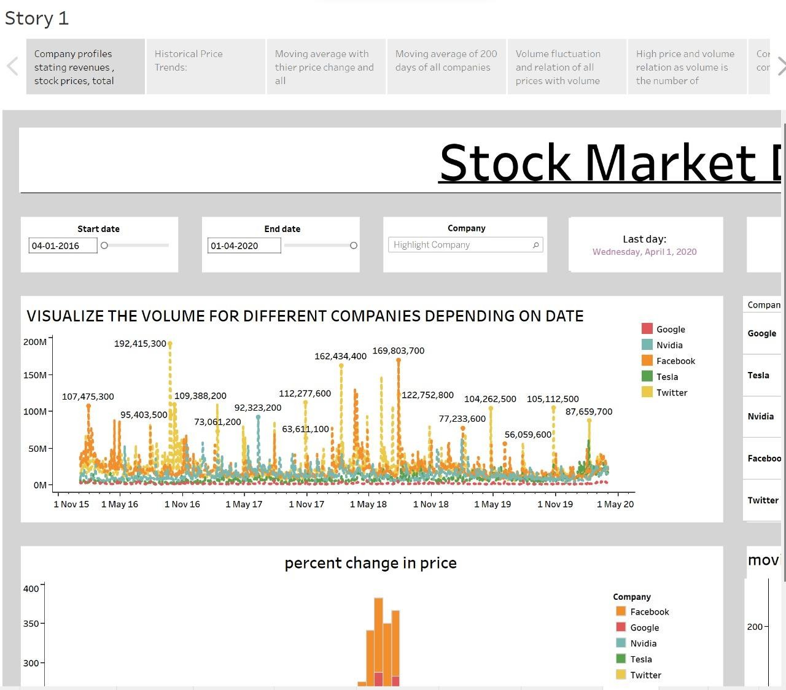

This dashboard compiles multiple visualizations, offering a comprehensive overview of key stock market metrics. It includes charts displaying historical price trends, moving averages, and volume data for various companies. The histogram illustrates the distribution of price changes, providing insights into market volatility. Additionally, detailed tables showcase specific company data, such as closing prices, percentage changes, and trading volumes. By consolidating these diverse visualizations, the dashboard enables users to analyze stock performance, identify patterns, and make data-driven investment decisions, enhancing their understanding of the market's dynamics and individual company behavior.

volume as size
In this visualization, imagine a collection of bubbles representing Apple's stock trading activity. Each bubble represents a specific trading day, with its size indicating the trading volume (larger bubbles for higher volumes). The vertical position of the bubbles represents the highest stock price on that day.
By selecting Apple in the filters, the visualization focuses solely on Apple's trading data. The labels display the highest stock prices, while the bubble sizes illustrate the trading volumes for each corresponding day.

This visual representation allows for an immediate comparison between trading volumes and stock prices, helping you quickly identify days with both high trading activity and significant price movements. It simplifies complex trading data into an intuitive, visually engaging format, aiding investors in understanding the relationship between trading volumes and stock prices for Apple.
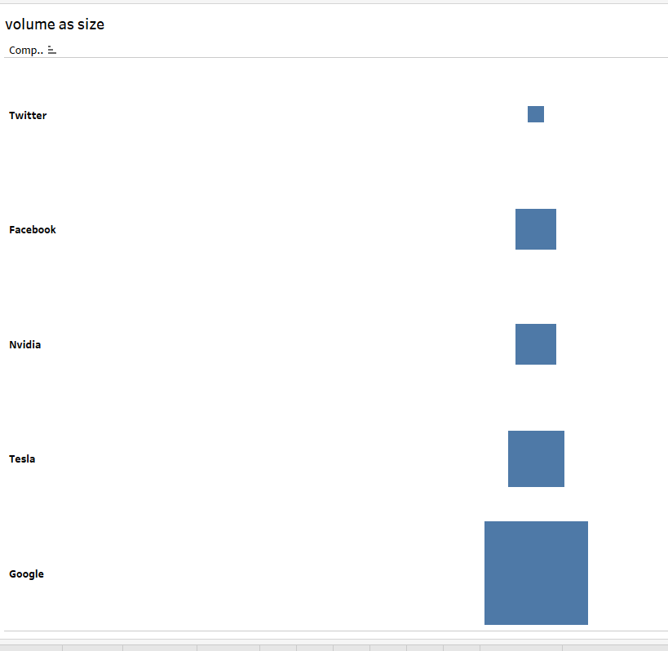

- Multiple chart
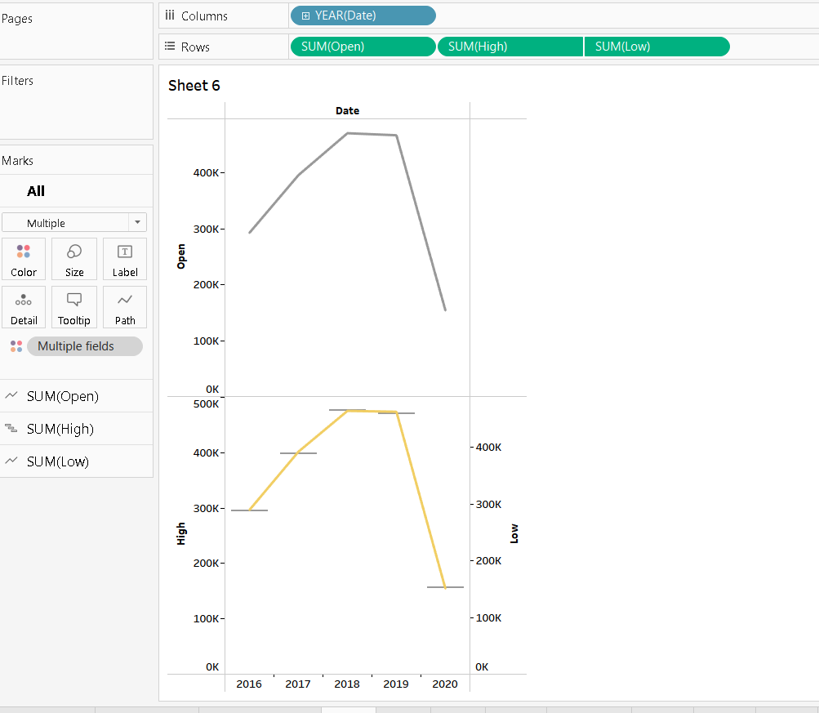
This graph shows how stock prices changed over multiple days. Dates are on the bottom, and the graph displays the opening, high, and low prices on the vertical axis. The use of the "Multiple" mark card enables simultaneous display of these metrics. Each line represents a different price value and is color-coded for clarity. By looking at these lines, viewers can easily understand how prices fluctuated daily, helping them see patterns and make sense of stock price movements in a straightforward way.

- Bar Graphs
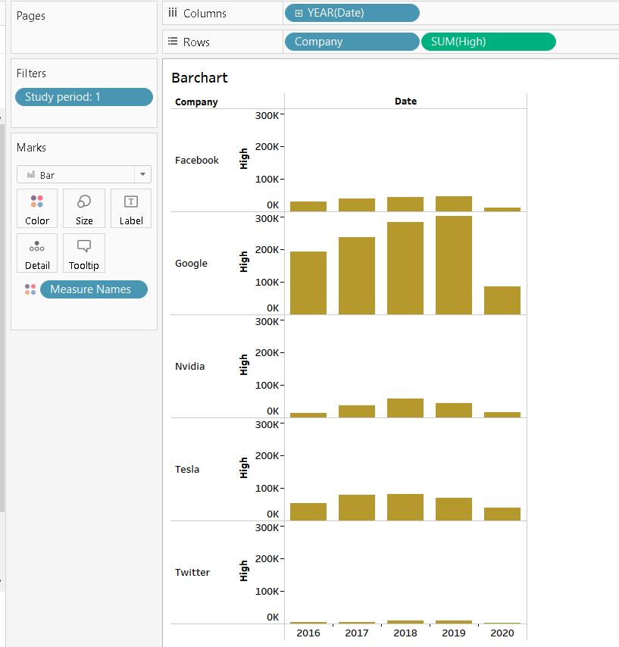
This bar graph shows the high prices of different companies on specific dates. Dates are on the horizontal axis (X-axis), while each bar represents a company's high stock price. The height of the bars indicates how high the stock price went for each company on a given date. By using colors, you can compare different companies easily. You can also filter the data for a specific study period, allowing you to focus on a particular timeframe. This graph helps you see which companies had the highest stock prices on different dates, providing a clear comparison and understanding of their market performance during the chosen period.

- Bubble chart
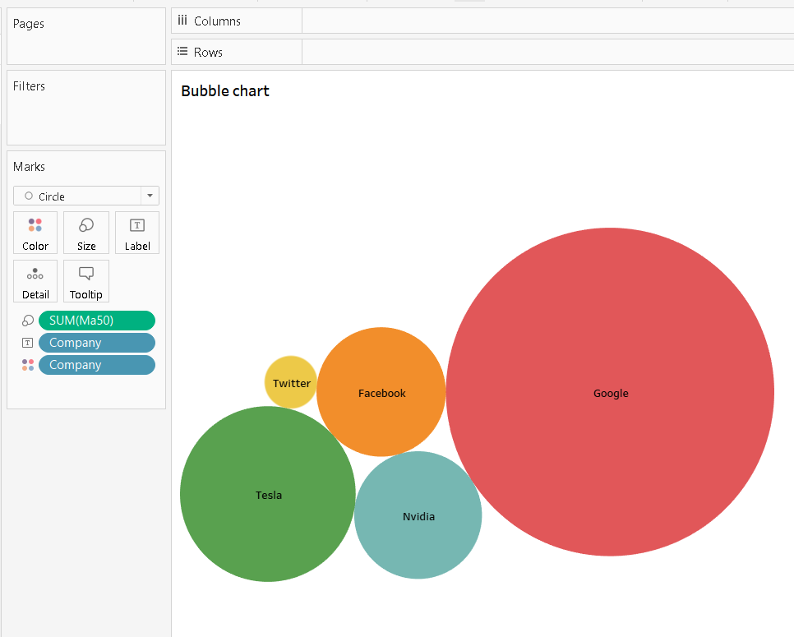
This bubble chart represents companies using circles, where each circle's size corresponds to its 50- day moving average (MA50). The bigger the circle, the higher the MA50 value, indicating a potentially stronger stock performance. Companies are color-coded, allowing easy identification.
Additionally, company names are labeled for clarity. This visualization enables quick comparison of companies based on their MA50 values, making it clear which companies are performing better in terms of this moving average metric. Larger circles signify stronger trends, providing a straightforward way to assess and compare companies' short-term stock performance.

- Gantt Chart
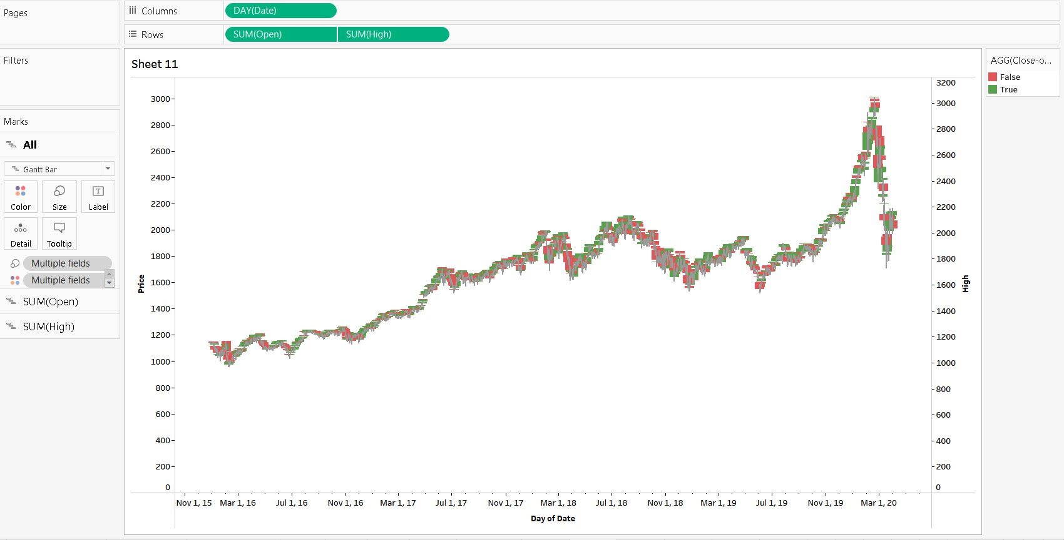

In this Candlestick chart, dates are represented on the horizontal axis (X-axis), showcasing specific time periods. Each 'candlestick' portrays the opening and closing prices as vertical bars, with the top of the bar indicating the high price and the bottom indicating the low price during that period.

The colors of the candlesticks represent market movement. Green or blue candles indicate that the closing price was higher than the opening price, suggesting a bullish trend. Red candles signify that the closing price was lower than the opening price, indicating a bearish trend. The length of the 'wick' above and below the candlesticks shows the price range, capturing the high and low prices.

In this visualization, color variations and bar lengths offer quick insights into market sentiment. Green or blue candlesticks suggest positive price movements, while red candlesticks indicate negative movements. By analyzing these patterns over time, traders and investors can make informed decisions about buying or selling stocks, helping them navigate the market effectively.

- Tree Map
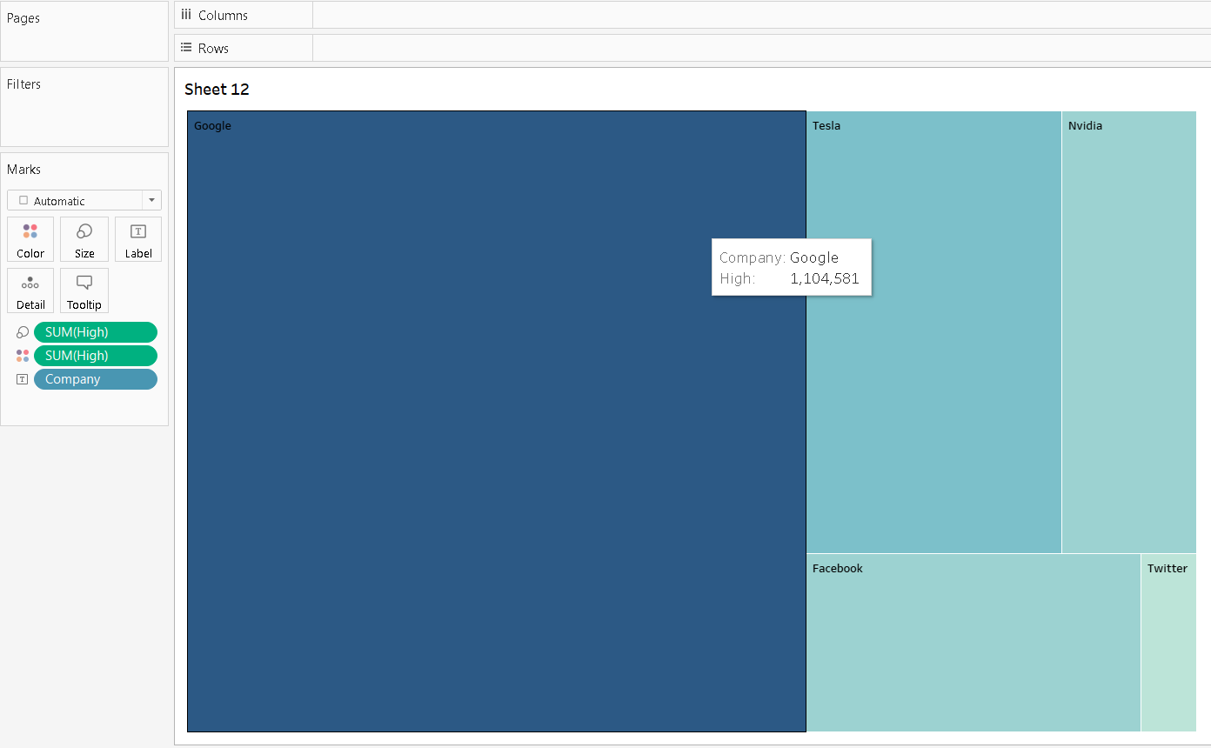
In this Tree Chart, each branch represents a company, and the size and color of the branches illustrate the high stock prices. Larger branches indicate higher high prices, and the color intensity signifies the magnitude of these prices. Company names are labeled on the branches. This visualization provides a clear comparison of high stock prices among different companies. The size differences indicate the variation in price levels, while color shades offer an additional layer of insight. This chart is helpful for understanding how high stock prices vary across companies, aiding investors in identifying trends and potential investment opportunities in a visually intuitive manner.

- Bar Chart
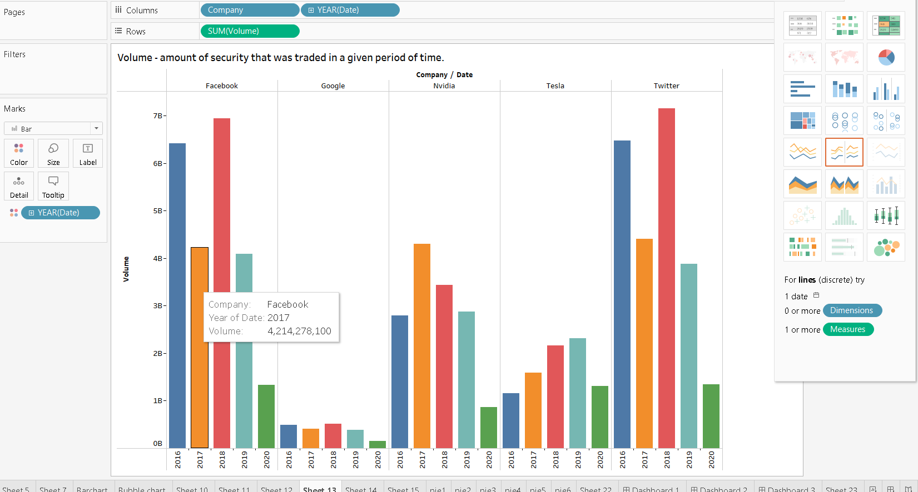
In this Bar Chart, companies are displayed along the horizontal axis (X-axis), and each bar represents the total trading volume for a specific year. The height of the bars indicates the volume of shares traded, while different colors represent different years. By looking at the bars, you can easily compare how trading volumes have varied for each company across different years. This chart provides a straightforward way to understand which years had significant trading activity for specific companies. It's a useful visual tool for investors to spot trends, compare trading volumes, and gain insights into the market behavior for different companies over the years.

- Volume - amount of security that was traded in a given period of time.

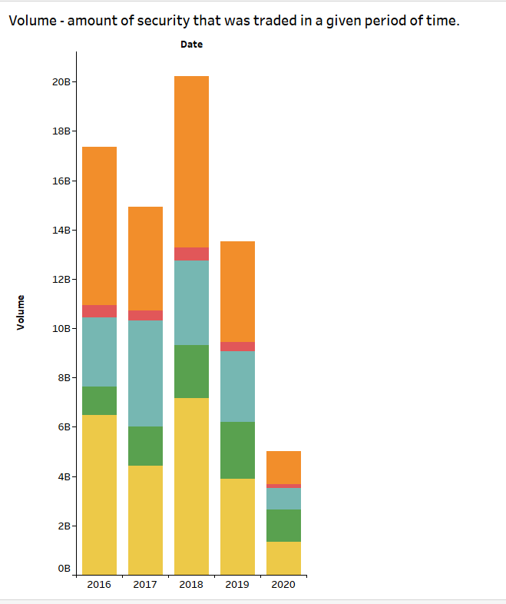

- Heap Map
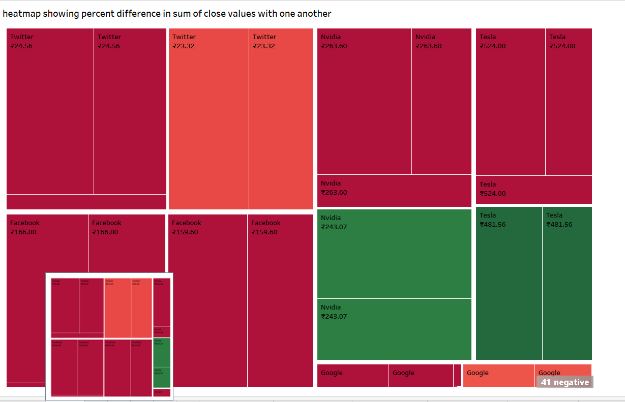

Moving average -200 of apple yearwise

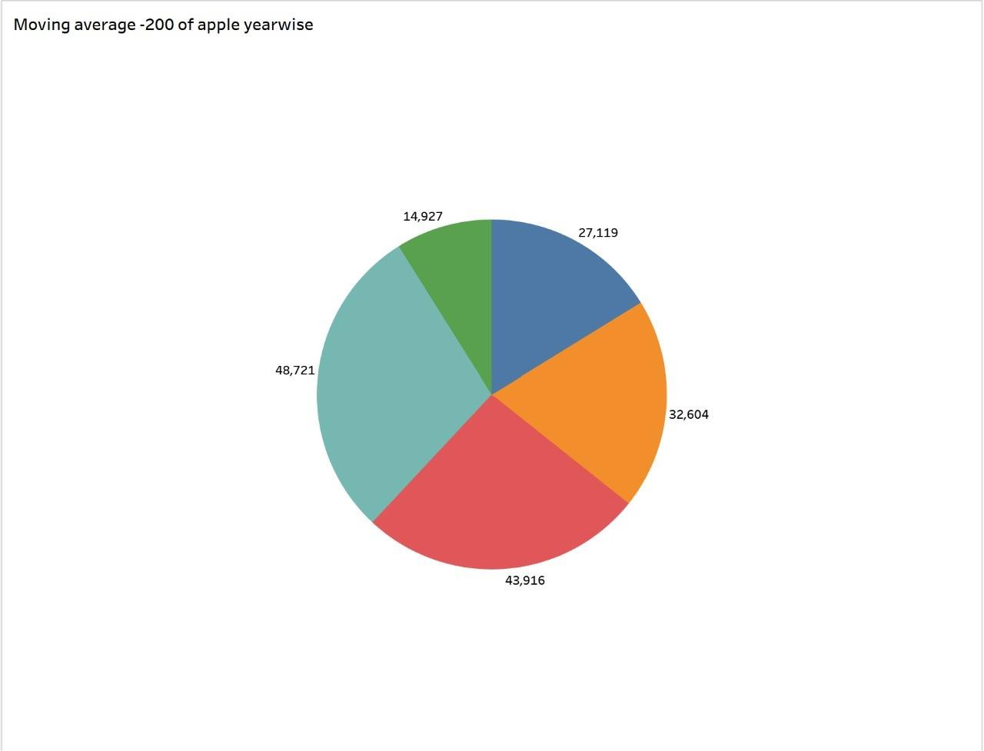
In this Pie Chart, each slice represents a year, distinguished by different colors. The size of each slice corresponds to the total value of the 200-day Moving Average (MA200) for that year. The chart focuses specifically on data for the company Apple due to the applied filter.
  - Colors (Year): Different colors distinguish different years, making it easy to identify each period.
  - Slices: Each slice illustrates the proportion of the total MA200 value in a particular year, showcasing its contribution to the whole dataset.
  - Size of Slices: Larger slices indicate years with higher MA200 values, reflecting more substantial long-term trends for Apple's stock.

By observing this chart, you can quickly grasp how Apple's long-term average trends (MA200 values) have varied over different years. The chart simplifies complex data, highlighting the relative significance of these trends specifically for Apple, making it a valuable tool for investors to assess the company's historical market stability and potential investment opportunities.

Moving average -200 of facebook yearwise
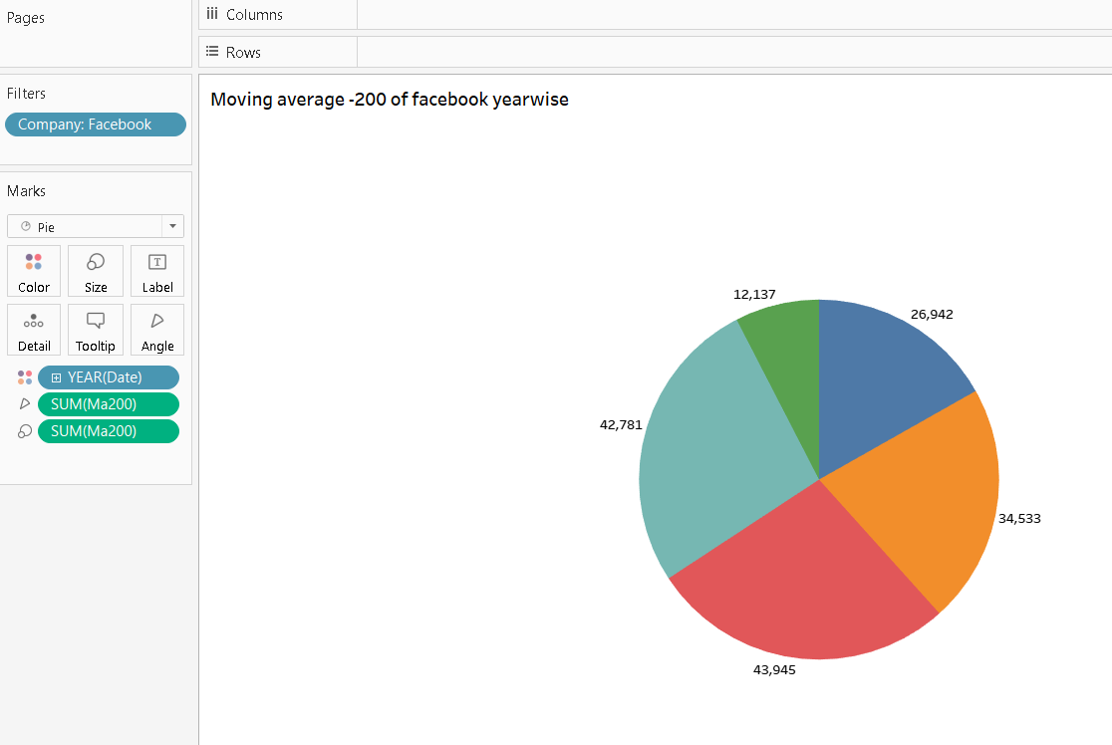

In this Pie Chart, each colorful slice represents a specific year, distinguished by different colors. The size of each slice corresponds to the total value of the 200-day Moving Average (MA200) for that year. The chart focuses exclusively on data for the company Facebook due to the applied filter.

- Colors (Year): Different colors represent different years, making them easily distinguishable.
- Slices: Each slice illustrates the portion of Facebook's MA200 value for a particular year, offering insights into its long-term trends.
- Size of Slices: Larger slices indicate years with higher MA200 values, reflecting more substantial long- term trends for Facebook's stock.
By observing this chart, you can swiftly understand how Facebook's long-term average trends (MA200 values) have varied across different years. The chart simplifies complex data, emphasizing the relative importance of these trends specifically for Facebook. It serves as a valuable tool for investors to assess the company's historical market stability and identify potential investment patterns.

Moving average -200 of google yearwise

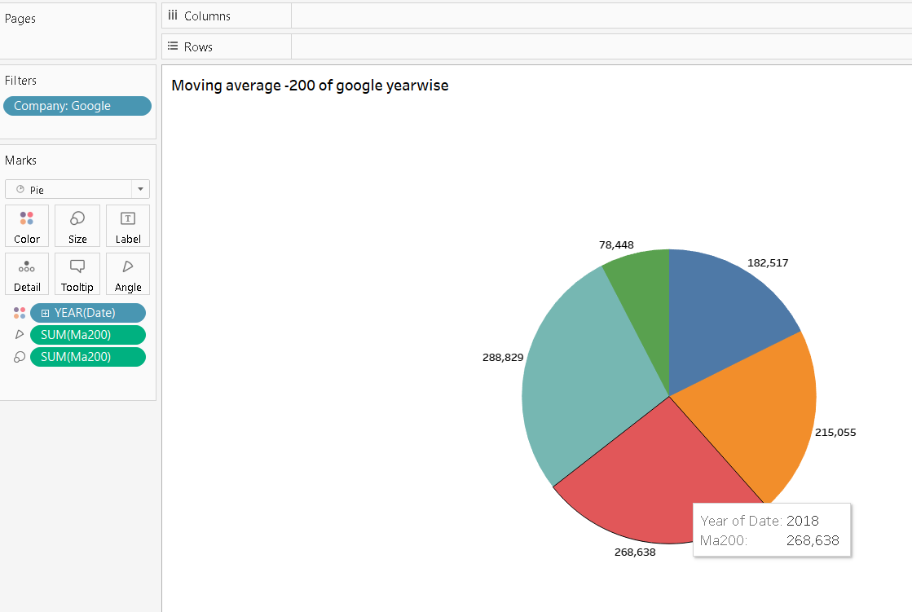

In this Pie Chart, each vibrant slice represents a specific year for the company Google, with different colors for easy distinction. The size of each slice corresponds to the total value of the 200-day Moving Average (MA200) for that respective year.
  - Colors (Year): Unique colors signify different years, allowing easy year identification.
  - Slices: Each slice illustrates the proportion of Google's MA200 value for a specific year, offering insights into its long-term trends.
  - Size of Slices: Larger slices indicate years with higher MA200 values, reflecting more substantial long-term trends for Google's stock.

By observing this chart, you can swiftly grasp how Google's long-term average trends (MA200 values) have varied across different years. The chart simplifies complex data, highlighting the relative significance of these trends specifically for Google. It serves as a valuable tool for investors to assess the company's historical market stability and identify potential investment patterns.

Moving average -200 of nvidia yearwise
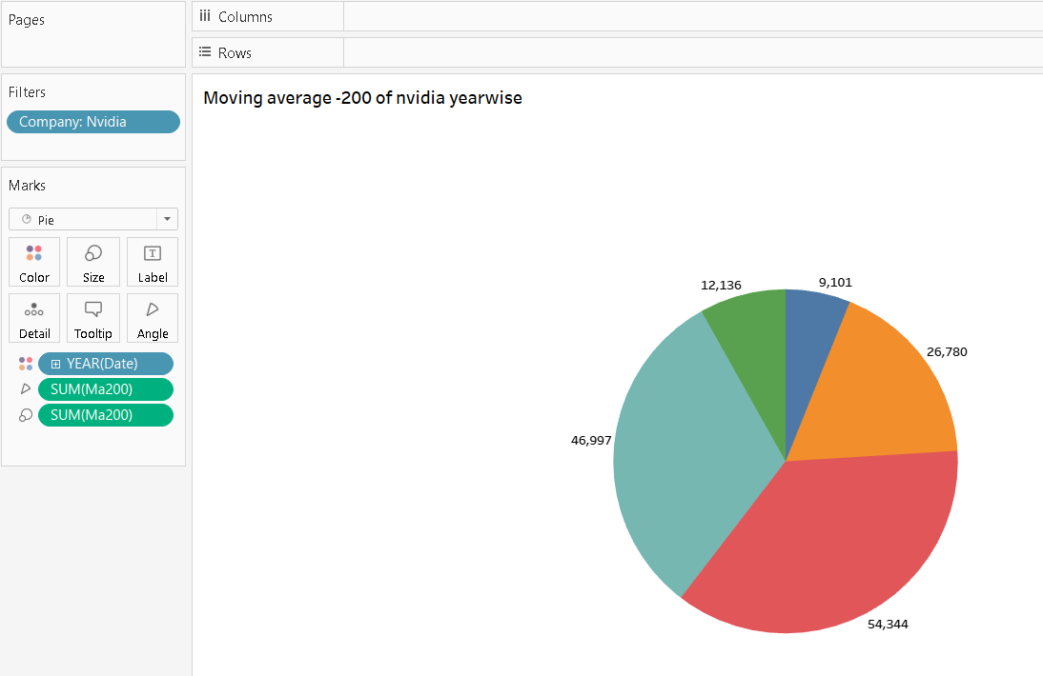
In this Pie Chart, each distinct slice represents a specific year for the company Nvidia, distinguished by different colors. The size of each slice corresponds to the total value of the 200-day Moving Average (MA200) for that particular year.
- Colors (Year): Different colors signify different years, making them easily identifiable.
- Slices: Each slice shows the proportion of Nvidia's MA200 value for a specific year, offering insights into its long-term trends.
- Size of Slices: Larger slices indicate years with higher MA200 values, representing stronger long- term trends for Nvidia's stock.
By looking at this chart, you can quickly understand how Nvidia's long-term average trends (MA200 values) have varied across different years. The chart simplifies complex data, emphasizing the relative importance of these trends specifically for Nvidia. It serves as a valuable tool for investors to assess the company's historical market stability and identify potential investment opportunities.

Moving average -200 of tesla yearwise
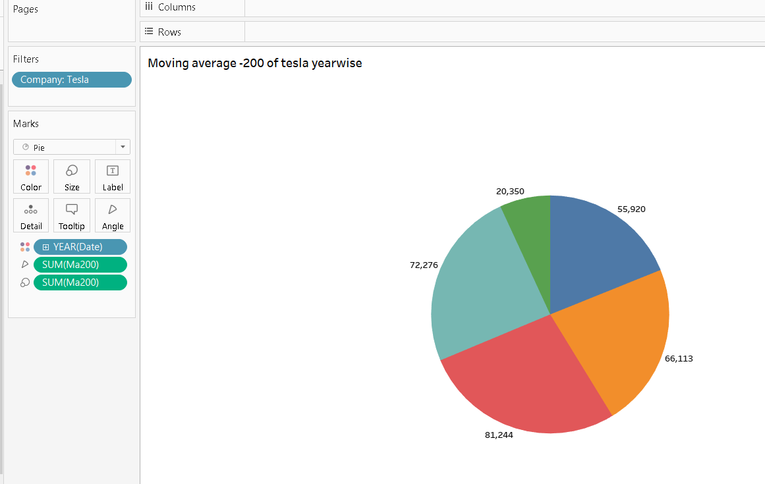

In this Pie Chart focused on Tesla, imagine it as a delicious pie where each slice represents a different year. The colors make each year distinct, while the size of each slice represents the strength of Tesla's 200-day Moving Average (MA200) trend during that time.
- Colors (Year): Vibrant colors distinguish each year, making them visually appealing and easy to differentiate.
- Slices: Each slice is like a piece of the pie, displaying the proportion of Tesla's MA200 value for a specific year.
- Size of Slices: Larger slices mean Tesla had a stronger, more significant trend during that year, making it a substantial part of the "pie."
This unique visualization lets you "taste" Tesla's performance over different years, with bigger slices indicating more robust trends, akin to savoring the sweetest parts of a pie. It's a creative and flavorful way to understand Tesla's historical market trends.

Moving average -200 of twitter yearwise
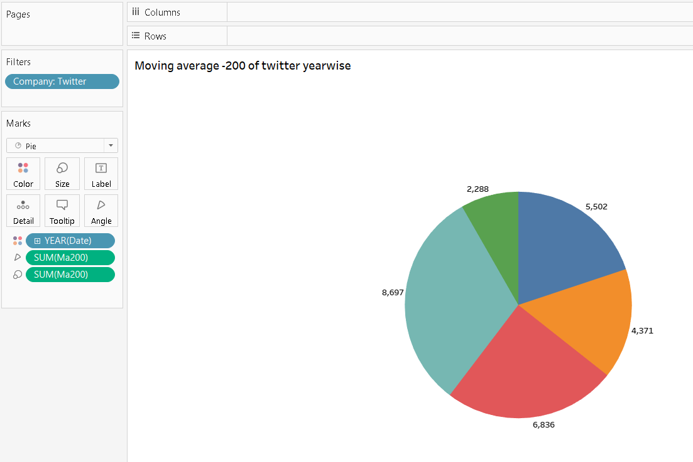

Imagine this Pie Chart as a unique Twitter conversation. Each colorful slice represents a specific year, akin to a different topic in the conversation.
- Colors (Year): Distinct colors symbolize diverse conversation topics or years, making them visually appealing and easy to distinguish.
- Slices: Each slice represents a conversation topic (year) on Twitter, highlighting the proportion of Twitter's MA200 value for that specific year.
- Size of Slices: Larger slices indicate more significant trends, analogous to the liveliest and most engaging discussions within each topic.
In this visual representation, you can picture Twitter's performance over the years as engaging conversations, with larger slices representing the most noteworthy trends or popular topics in the "Twitter conversation." It's a creative way to understand Twitter's historical market trends, visualizing them as dynamic and engaging discussions within different time frames.

PARETO CHARTS
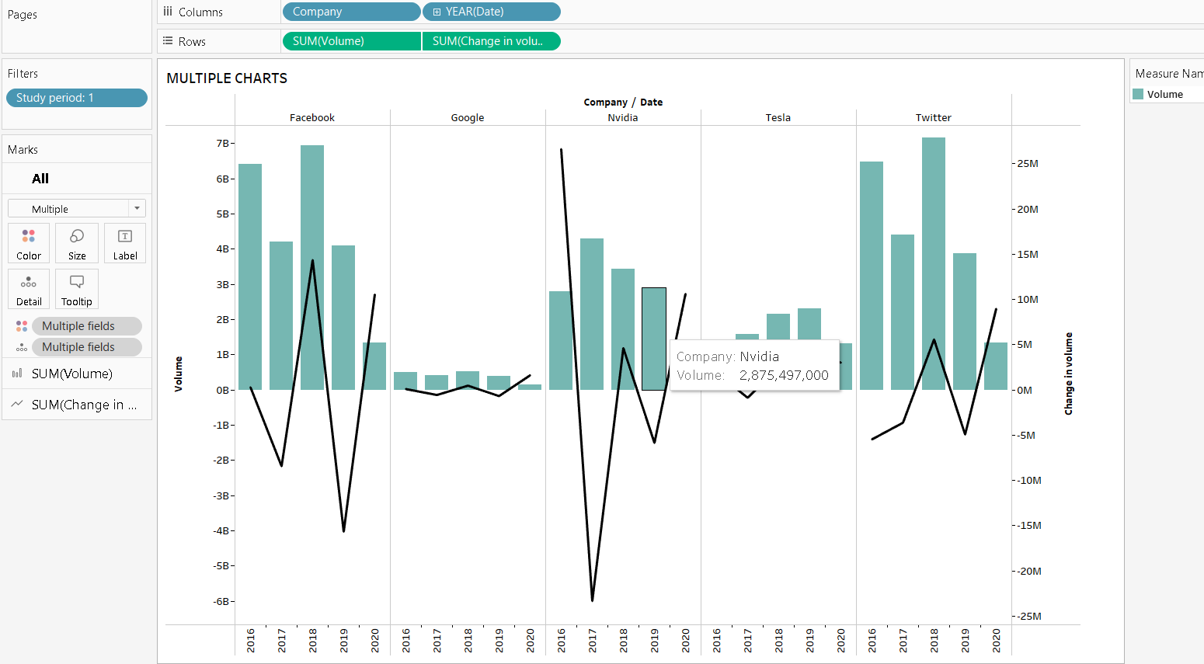

This multiple chart displays trading data over time, with dates and company names on the X-axis. The Y-axis shows total trading volume and volume changes. Each data point is color-coded and detailed for clarity. By filtering study periods, users can focus on specific time frames. The bar chart format emphasizes total trading volume, enabling easy identification of high and low trading periods for each company. Detailed volume changes offer insights into fluctuations, aiding in pinpointing specific trends. Overall, this visualization provides a comprehensive view of trading dynamics, assisting in analyzing market activity and patterns for various companies during specific study periods.

- Change in price of facebook yearwise
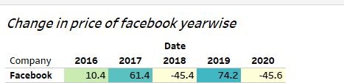

Imagine this visualization as a colorful mosaic reflecting Facebook's stock price changes across different years. Each square represents a specific year, forming a clear chronological pattern. The height of the squares signifies the extent of Facebook's price fluctuations in each year, with taller squares indicating more significant changes.
The vibrant colors inside each square act as a visual indicator: darker tones represent years with substantial price movements, allowing you to identify periods of notable volatility effortlessly. Additionally, the precise change in price is displayed within the squares, providing specific numerical values.

By examining this mosaic, you can easily compare Facebook's yearly price variations. It's like looking at a collection of vivid tiles, each representing a different chapter in Facebook's market story. This intuitive presentation simplifies intricate financial data, enabling you to understand Facebook's stock performance in a straightforward and visually engaging manner.

- Change in price of apple yearwise
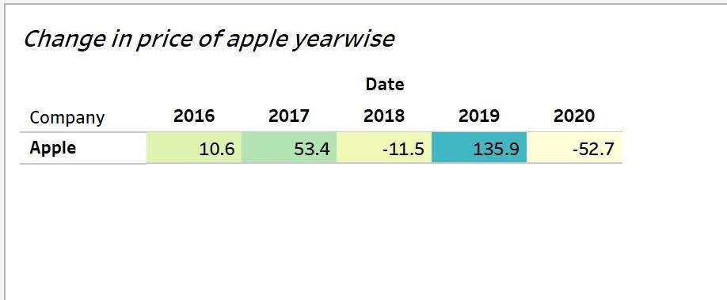

Picture this visualization as a colorful grid illustrating Apple's stock price changes year by year. Each square represents a specific year, forming a visual timeline. The height of the squares represents how much Apple's stock price fluctuated in that year, with taller squares indicating more significant changes.

Inside each square, vibrant colors tell a story: darker shades indicate years with substantial price shifts, allowing you to spot periods of notable volatility at a glance. Additionally, the exact change in price is displayed within the squares, providing specific numerical values.

By observing this grid, you can effortlessly compare Apple's yearly price fluctuations. It's akin to looking at a series of colorful tiles, each representing a different chapter in Apple's market journey. This visual representation simplifies complex financial data, making it easy to grasp Apple's stock performance in an intuitive and visually appealing manner.

- Change in price of google yearwise
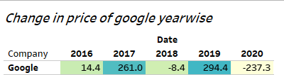

Imagine this visualization as a colorful mosaic of Google's stock price changes over the years. Each square on the chart represents a specific year, neatly arranged along the timeline. The height of the squares illustrates the extent of Google's price fluctuations in each year - taller squares indicating more significant changes.
The vibrant colors inside the squares offer a quick visual guide: darker hues represent years with substantial price movements, making it effortless to identify periods of notable volatility.
Additionally, the exact change in price is displayed within each square, providing precise numerical details.

By examining this mosaic, you can easily compare Google's annual price variations. It's like flipping through a visual calendar, with each square telling the story of a different chapter in Google's market journey. This intuitive presentation simplifies complex financial data, allowing you to understand Google's stock performance in a straightforward and visually engaging manner.

- Change in price of nvidia yearwise
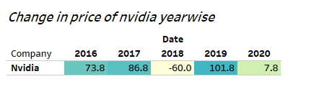

In this unique visualization, envision each square as a window into a specific year of Nvidia's stock price movement. The squares line up along the timeline, offering a clear view of how Nvidia's stock price changed each year. The height of each square represents the extent of these price fluctuations - taller squares indicate more significant changes.

The colors of the squares serve as a visual code: darker colors indicate years with substantial price shifts, making it easy to spot periods of high volatility. Additionally, the exact change in price is showcased inside each square, providing precise numerical data.
By observing this chart, you can effortlessly compare Nvidia's yearly price changes. It's akin to flipping through a visual calendar, each square capturing a different chapter in Nvidia's market story. This intuitive format simplifies intricate financial data, allowing you to grasp Nvidia's stock performance over the years in a straightforward and accessible manner.

- Change in price of tesla yearwise
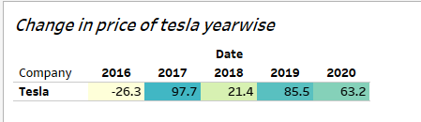

In this visualization, think of each square as a snapshot of a specific year in Tesla's stock price journey. The squares are neatly arranged along the timeline, each representing a year's change in price. The height of the square shows how much Tesla's stock price fluctuated in that particular year - taller squares indicate bigger price changes.
The colors of the squares provide an instant visual cue: darker colors represent more significant price swings, helping you quickly identify the most volatile years. Furthermore, the exact change in price is labeled inside each square, giving you precise numerical information.

By looking at this chart, you can easily compare Tesla's price changes year by year. The visual format simplifies complex financial data, offering a straightforward way to understand how Tesla's stock value has evolved over different years. It's a visual timeline that tells the story of Tesla's market performance in a glance.

- Change in price of twitter yearwise
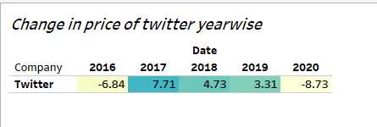
In this visualization, each square represents a specific year's change in price for the company Twitter. The squares are arranged along the X-axis based on the years (extracted from the date column). The height of each square on the Y-axis corresponds to the total change in price for Twitter in a particular

year. The color intensity of the squares indicates the magnitude of the price change, with darker shades representing more significant changes. Additionally, the exact change in price is displayed within each square. By observing the squares' positions and colors, viewers can easily discern the yearly price fluctuations for Twitter, providing a straightforward and visual way to understand the company's price trends over time.

- total change in price in all comapnies
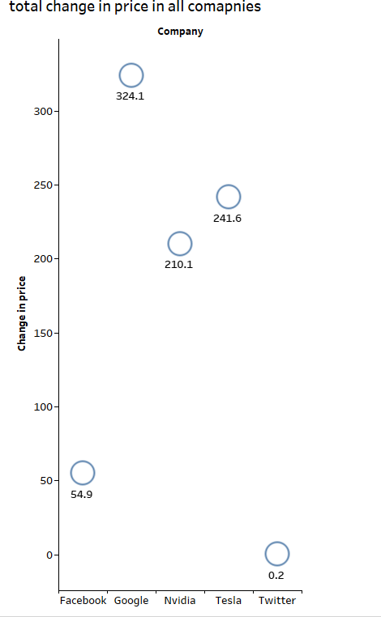

In this visualization, each company is represented by a unique shape. The vertical axis (Y-axis) displays the total change in price for each company. The position of the shape on the Y-axis signifies the magnitude of the price change, making it easy to compare companies. By examining the shapes' positions, investors can quickly identify which companies experienced significant price changes over the specified period. This visual representation simplifies complex data, providing a clear and intuitive comparison of price movements across different companies, aiding investors in understanding market trends and making informed decisions about their investments.

- Dashboard -2
The dashboard titled "Company Performance Overview" presents a holistic view of stock market trends using six distinct Pie Charts, each focusing on a different company: Apple, Facebook, Google, Nvidia, Tesla, and Twitter.
Pie Charts: Each Pie Chart visually represents a specific year's 200-day Moving Average (MA200) values. The slices, varying in size and color, denote the relative significance of each year's performance within the dataset. Different colors represent different years, making it easy to differentiate them.
The "Company Performance Overview" dashboard features six interactive Pie Charts, each representing a different company's 200-day Moving Average (MA200) values across specific years. Users can explore long-term trends for Apple, Facebook, Google, Nvidia, Tesla, and Twitter. Different colors distinguish years, while slice sizes indicate the strength of each year's market performance. The dashboard enables investors to identify stable periods and potential growth opportunities, offering a visually intuitive and user-friendly interface for strategic investment decisions.

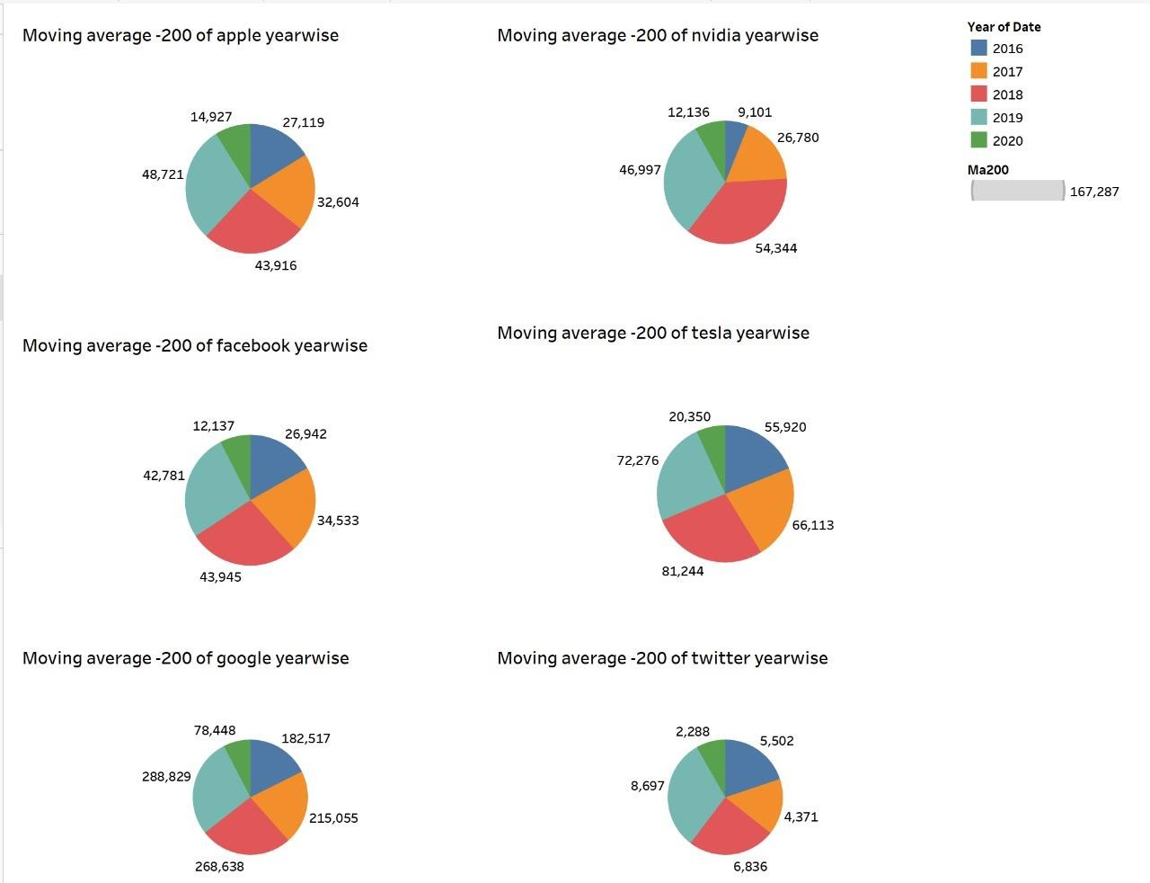

- Dashboard-3

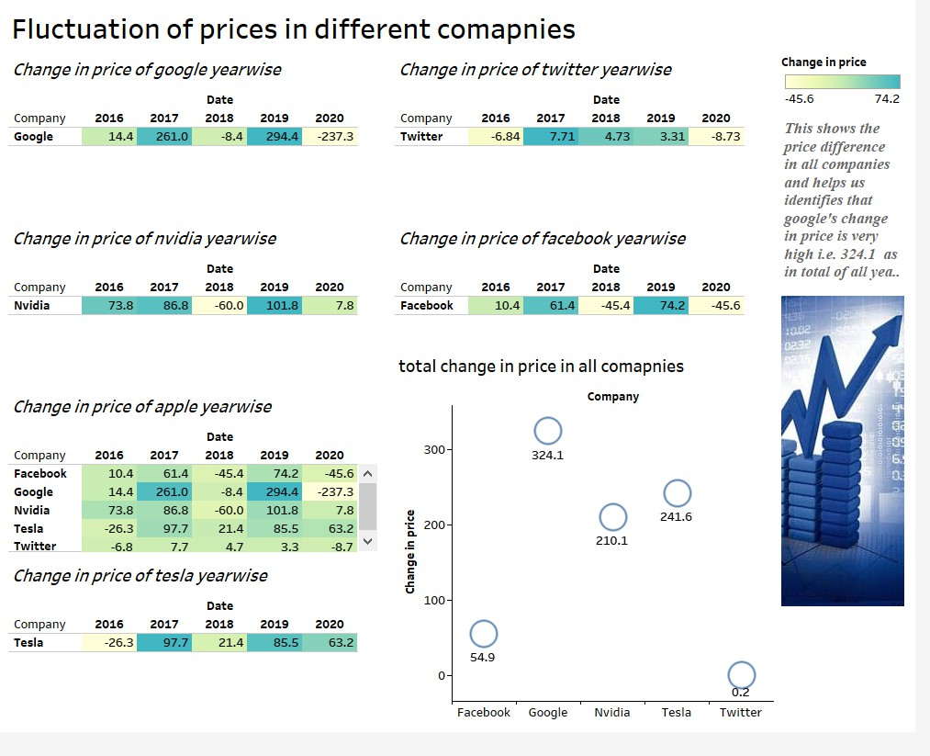

- Dashboard -4

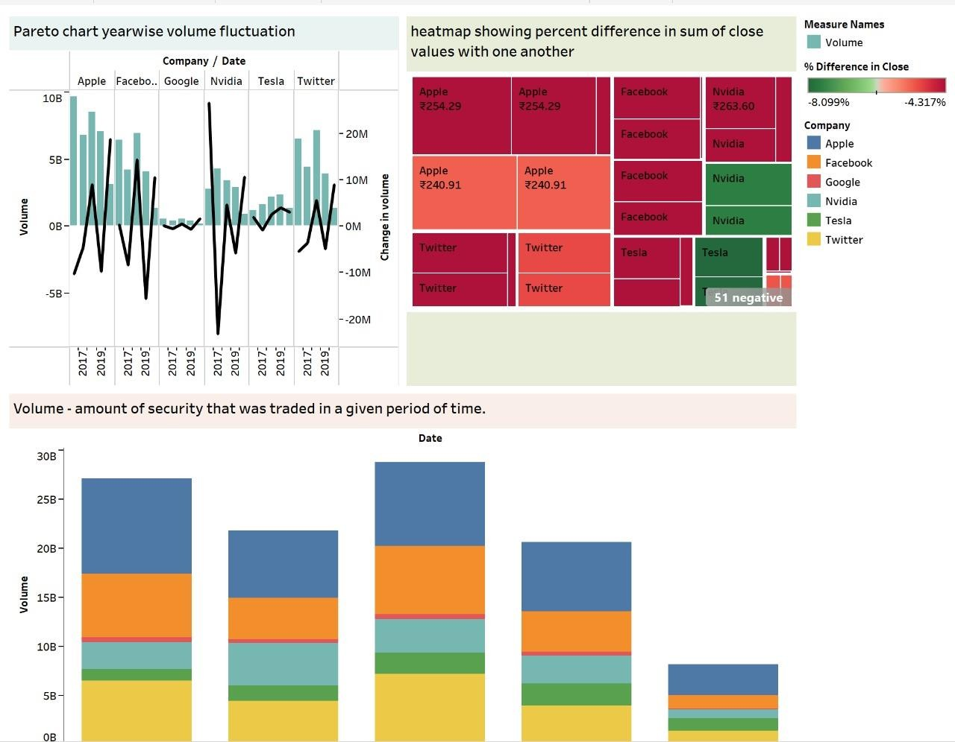

- Dashboard -5

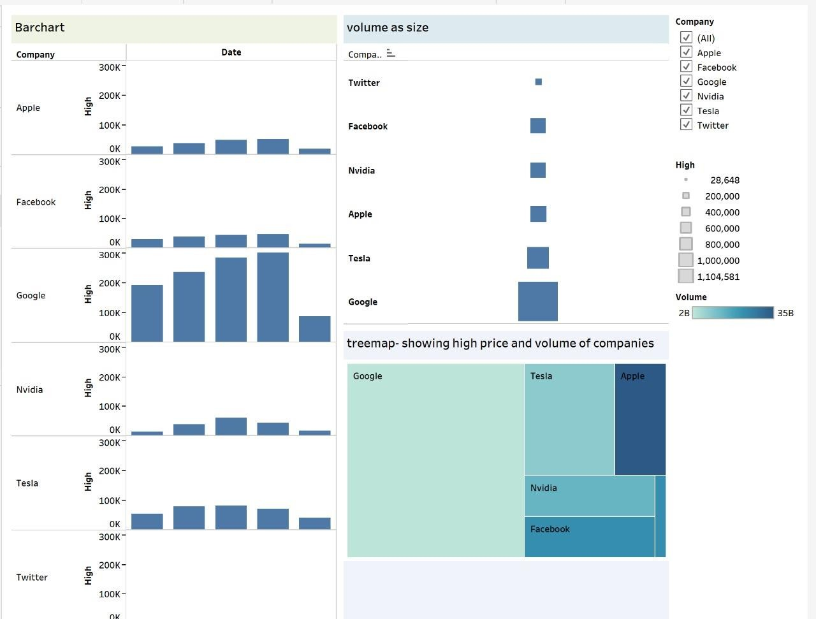

- Dashboard-6
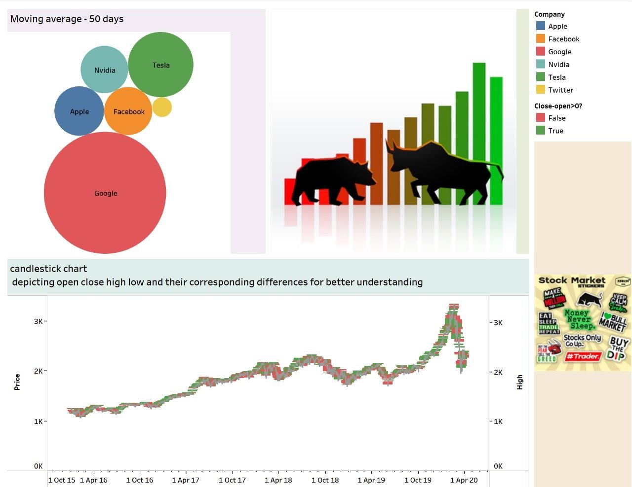

- Dashboard

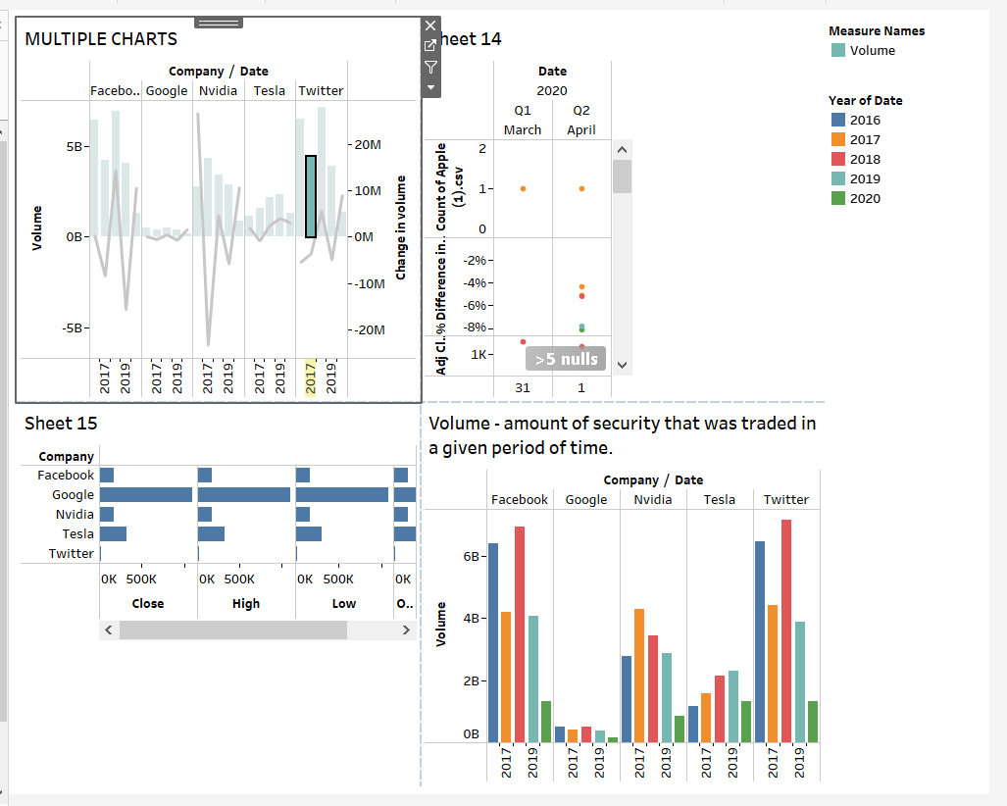

CONCLUSION
In conclusion, this project has successfully transformed extensive historical stock market data into meaningful insights through innovative data visualization techniques. By leveraging Tableau, we've provided a user-friendly interface to analyze and interpret market trends, trading volumes, and price variations for major NASDAQ-traded companies. The interactive visualizations have simplified complex financial data, making it accessible to both novice and experienced investors. The project has showcased the importance of visualization tools in empowering investors with actionable insights, enabling them to make informed decisions in the ever-changing stock market landscape.

Future Scope:
Looking ahead, there are several avenues for future exploration and enhancement of this project:

- Real-time Data Integration: Integrating real-time data feeds to the visualization tool would provide investors with up-to-the-minute insights, enabling quicker decision-making in volatile market conditions.
- Predictive Analytics: Implementing machine learning algorithms to forecast stock price movements based on historical data could provide valuable predictive insights, assisting investors in identifying potential market trends.

- Sentiment Analysis: Incorporating sentiment analysis tools to analyze news articles, social media, and market sentiments could offer additional context to stock price movements, aiding investors in understanding market psychology.

- Sector-wise Analysis: Extending the project to include sector-wise analysis could provide a broader perspective, allowing investors to compare companies within the same industry, thus aiding in sector- specific investment decisions.
- Mobile Application: Developing a mobile application with simplified versions of the visualizations would make the insights accessible on-the-go, catering to a wider audience of investors.

- Incorporating Fundamental Analysis: Integrating fundamental analysis metrics, such as earnings per share, price-to-earnings ratios, and dividend yields, into the visualizations could offer a comprehensive view, enabling investors to make well-rounded investment choices.

By exploring these future scopes, this project can evolve into a more robust and versatile tool, catering to the ever-evolving needs of investors and analysts in the dynamic world of stock market investments.

ADVANCE FEATURES
1.
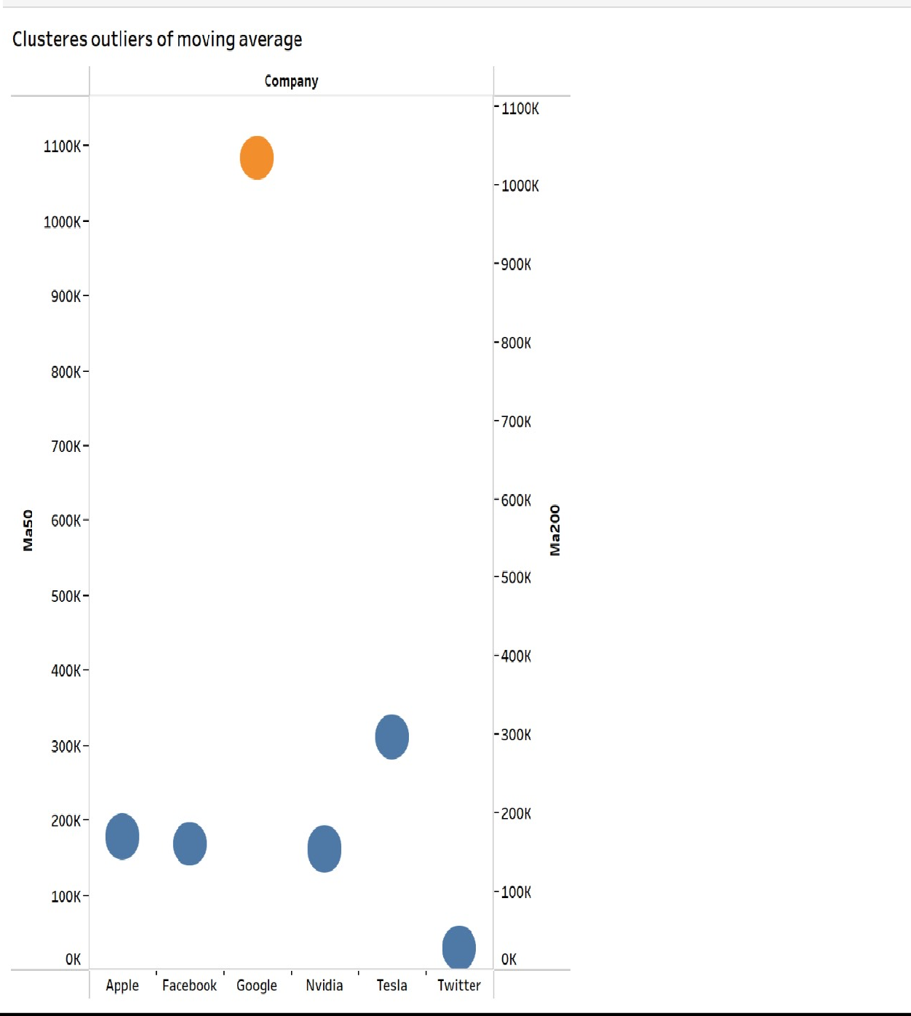

2.
